CREATE TABLE BANKS1

(acc_id INT PRIMARY KEY,

acc_name VARCHAR(100),

balance INT);

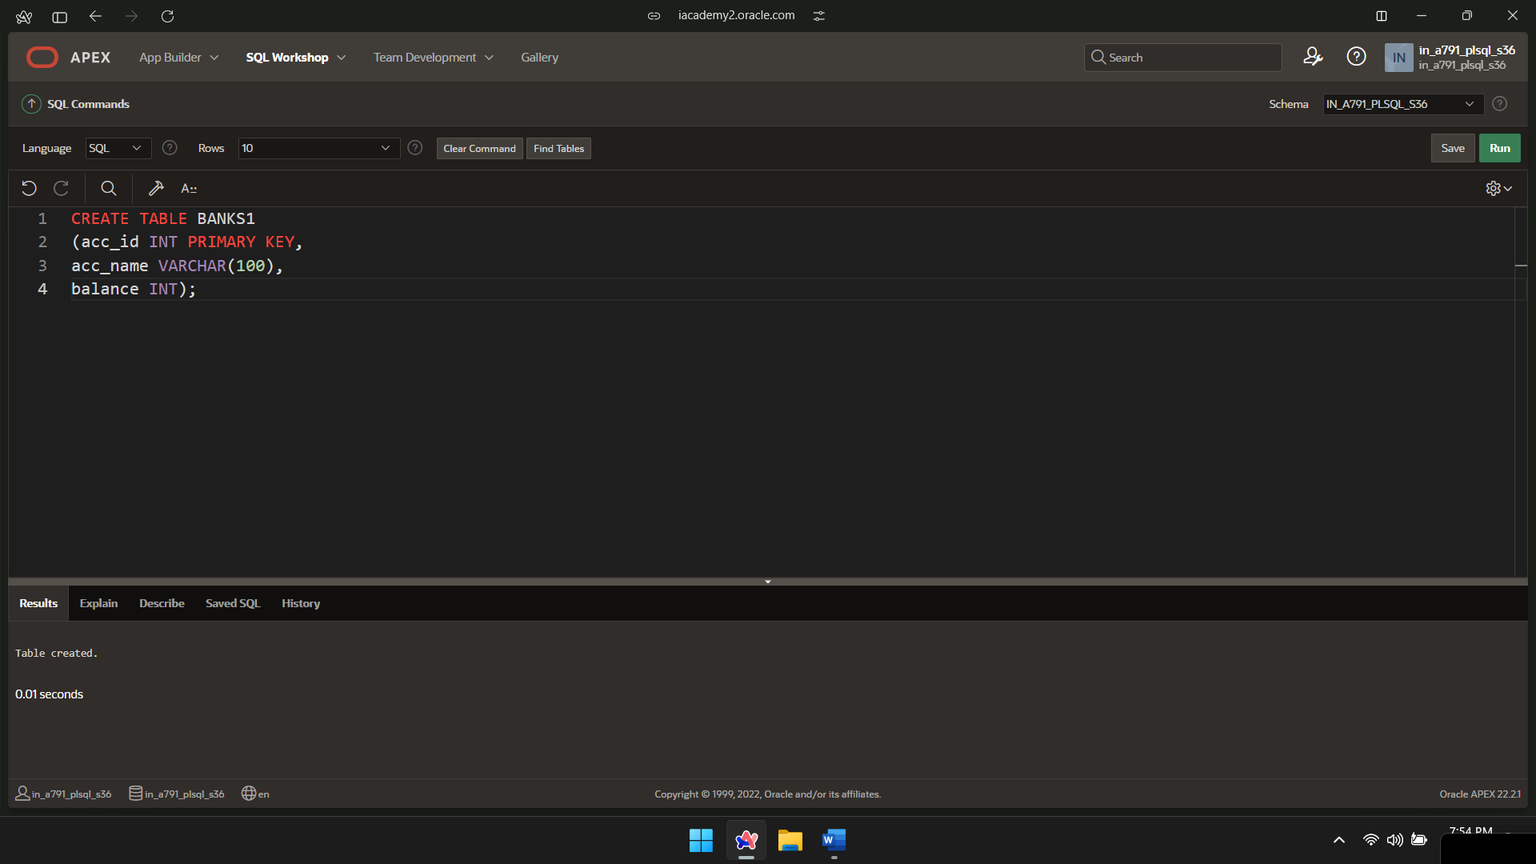

INSERT INTO BANKS1 VALUES(1,'name1',1000);

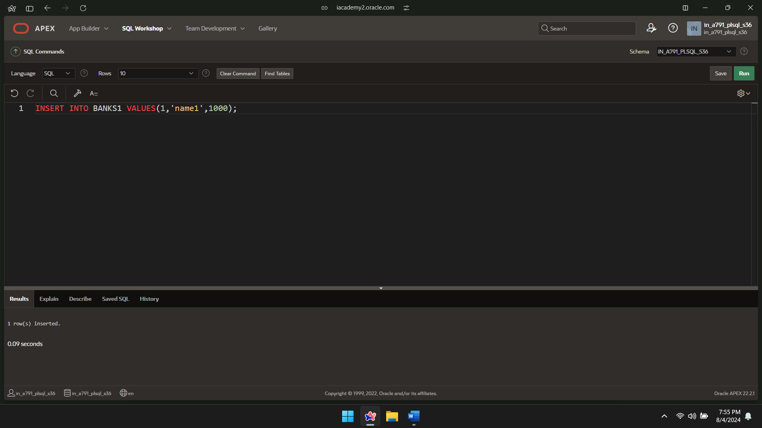

INSERT INTO BANKS1 VALUES(2,'name2',1500);

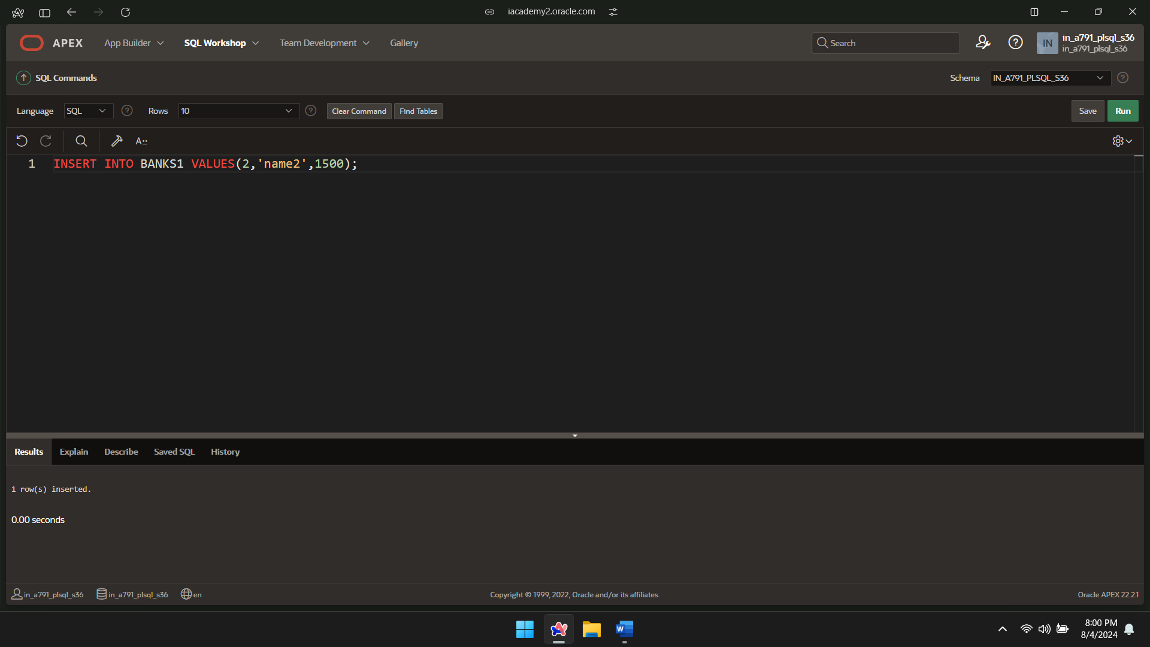

INSERT INTO BANKS1 VALUES(3,'name3',2000);

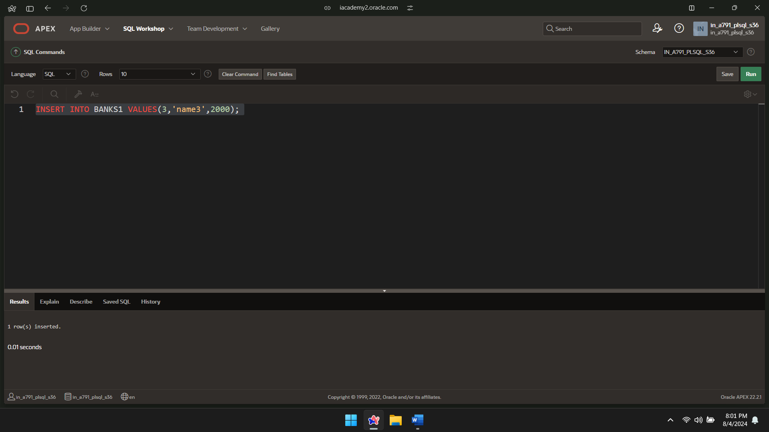

INSERT INTO BANKS1 VALUES(4,'name4',2500);

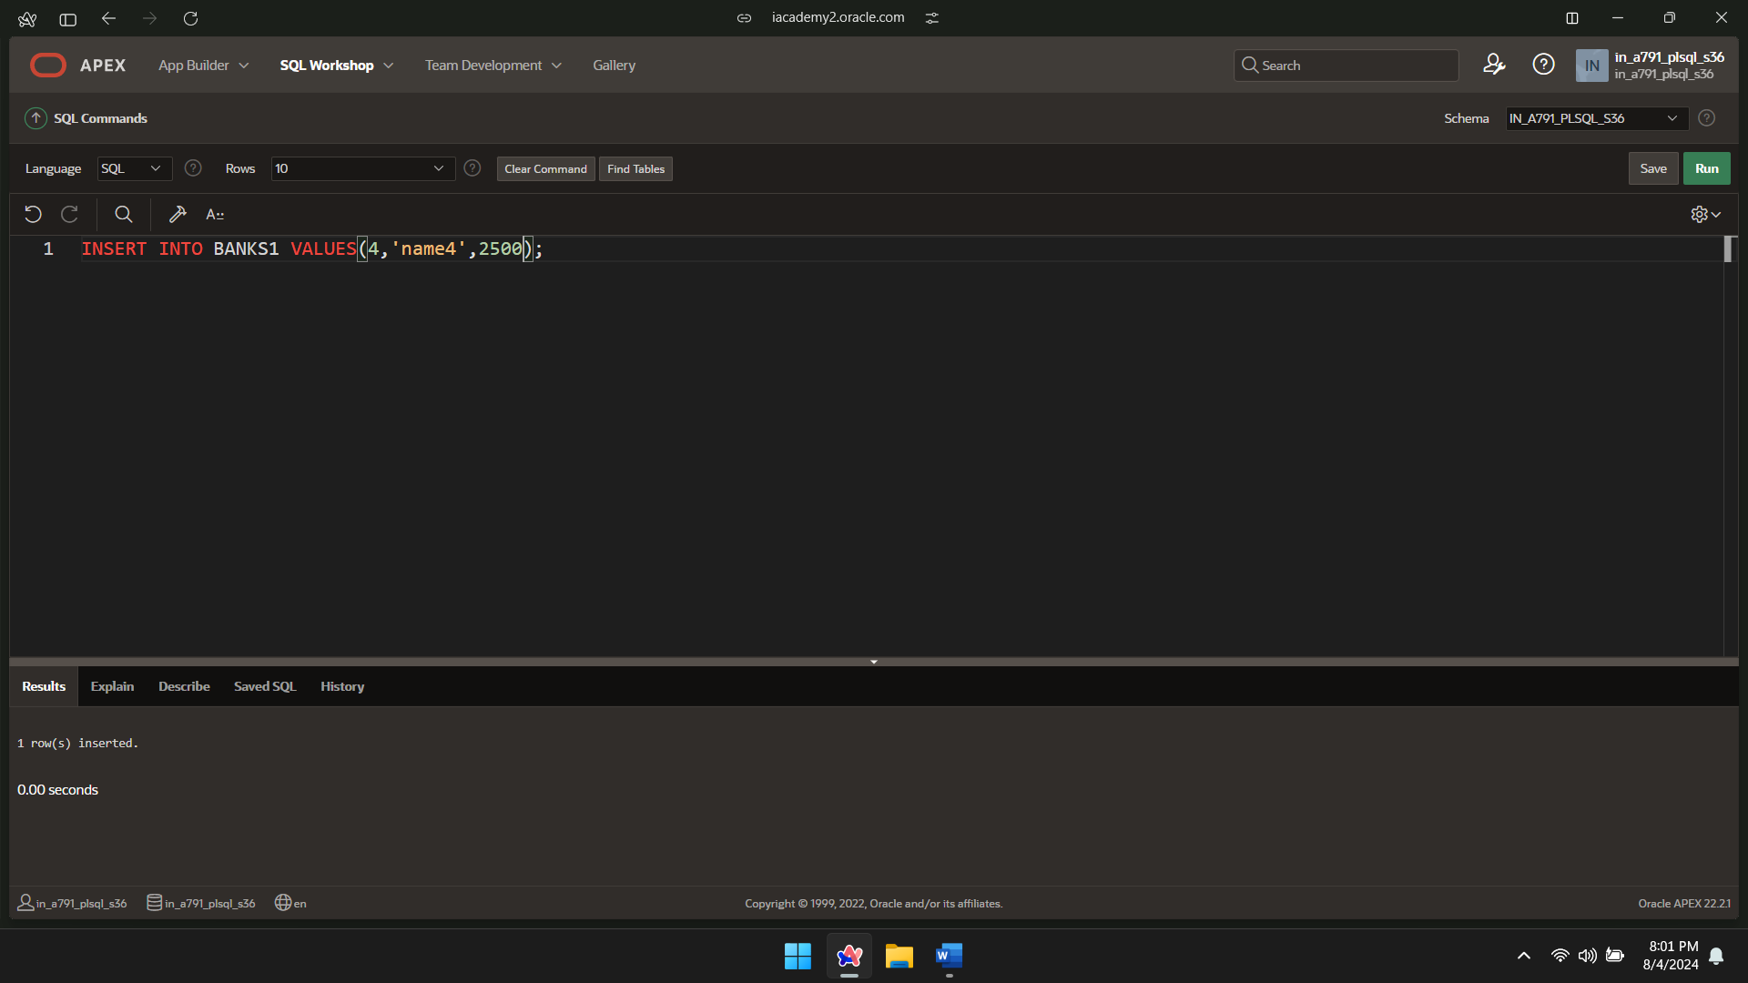

INSERT INTO BANKS1 VALUES(5,'name5',3000);

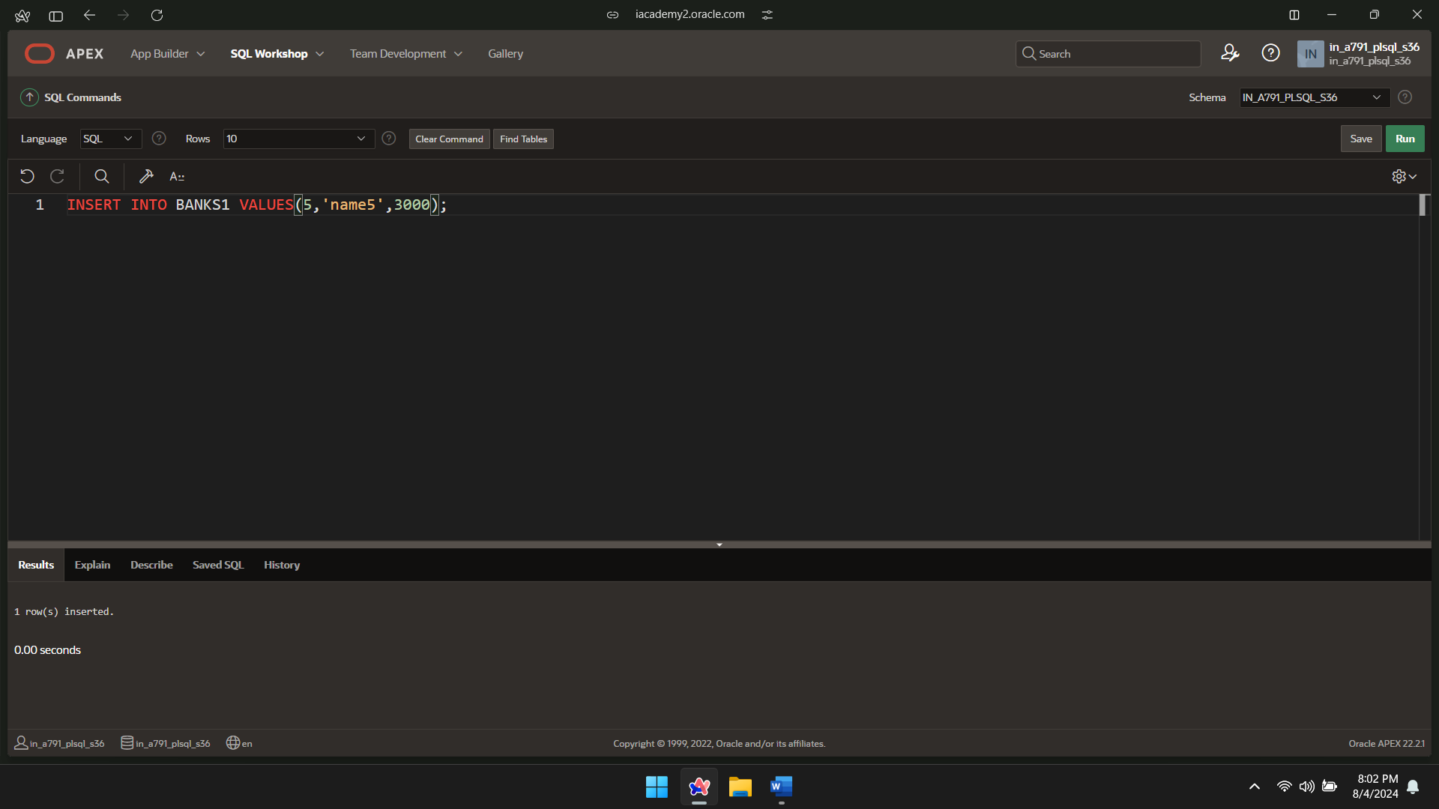

SELECT * FROM BANK1;

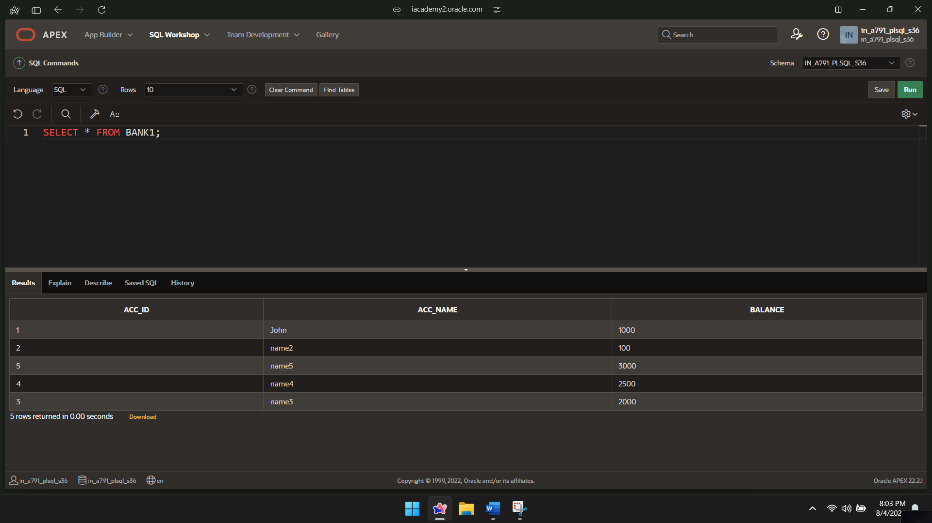

CREATE TABLE TRANSACTIONS1(trans_id INT PRIMARY KEY,acc_id INT,trans_type VARCHAR(50),amount INT,FOREIGN KEY(acc_id) REFERENCES BANKS1(acc_id));

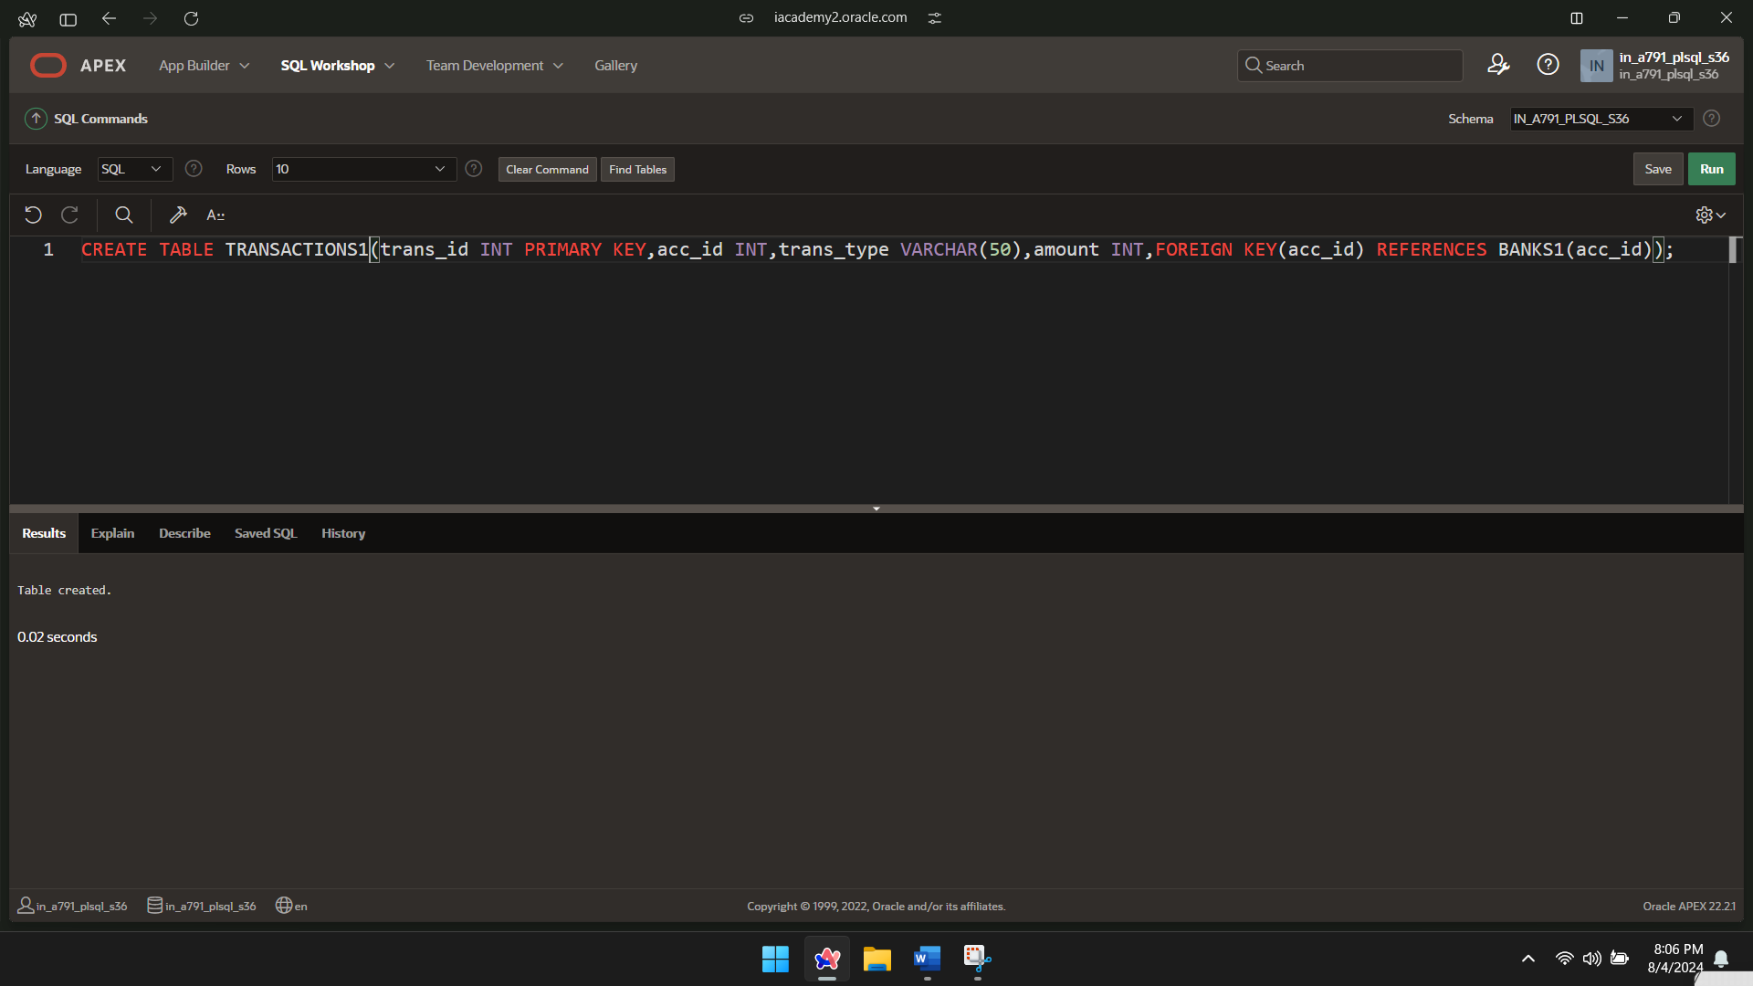

INSERT INTO TRANSACTIONS1 VALUES(101,1,'Deposit',500);

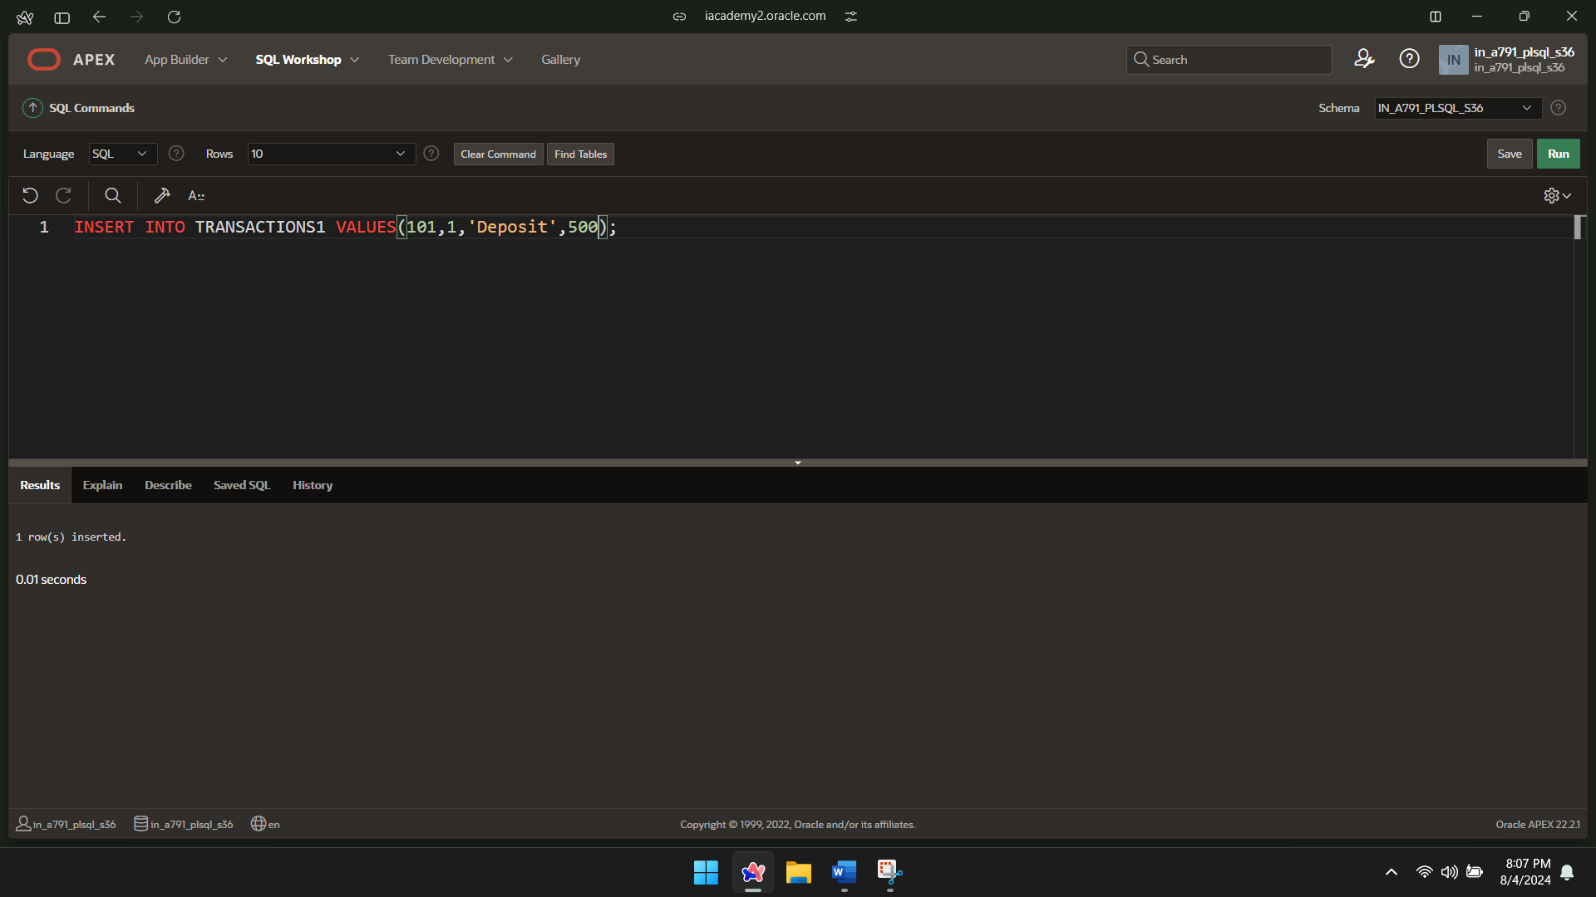

INSERT INTO TRANSACTIONS1 VALUES(102,2,'Withdrawal',700);

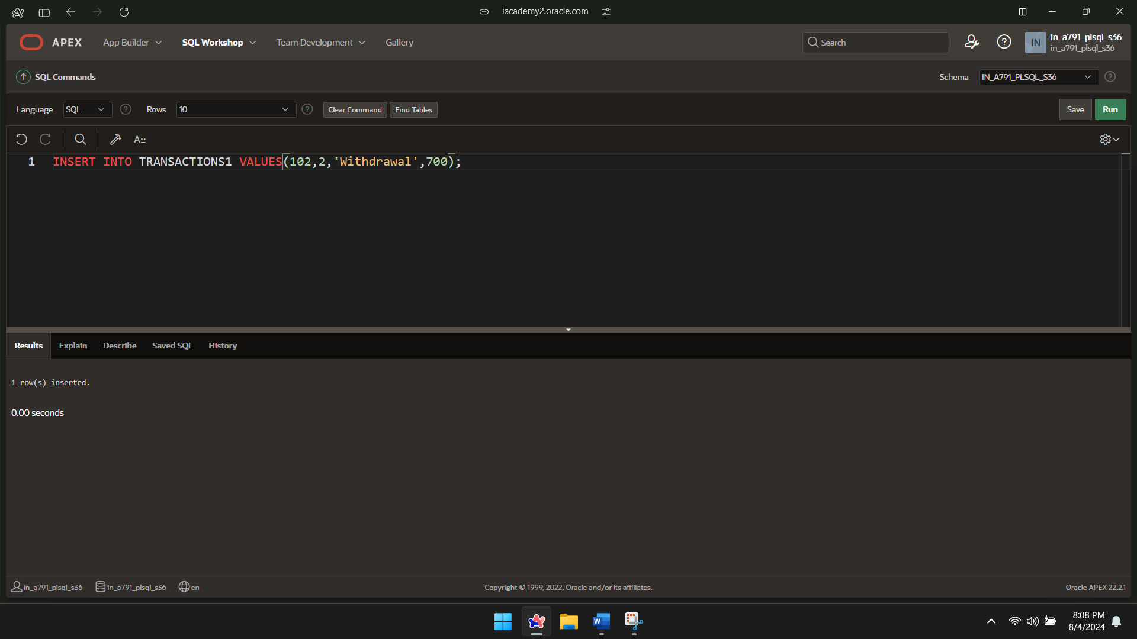

INSERT INTO TRANSACTIONS1 VALUES (103,3,'Deposit',1500);

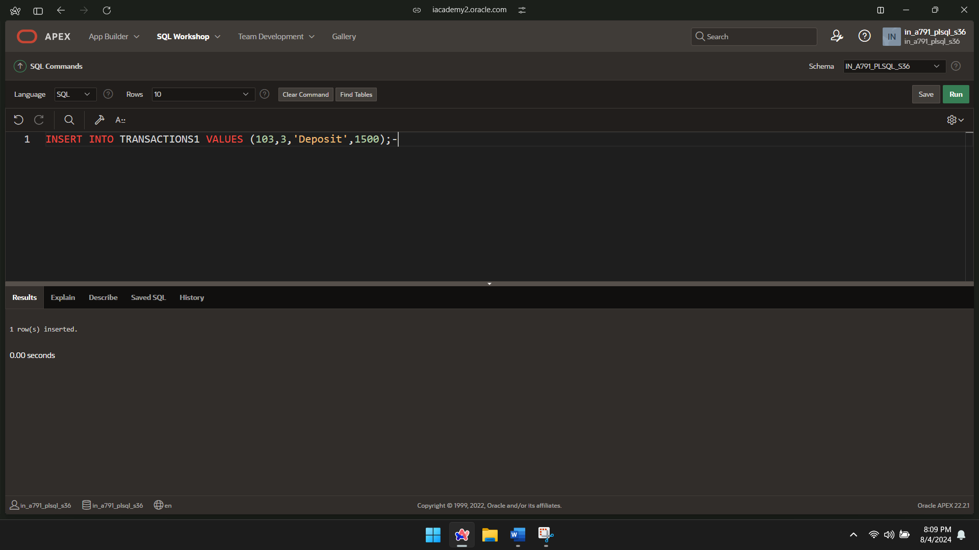  
INSERT INTO TRANSACTIONS1 VALUES (104,4,'Withdrawal',800);

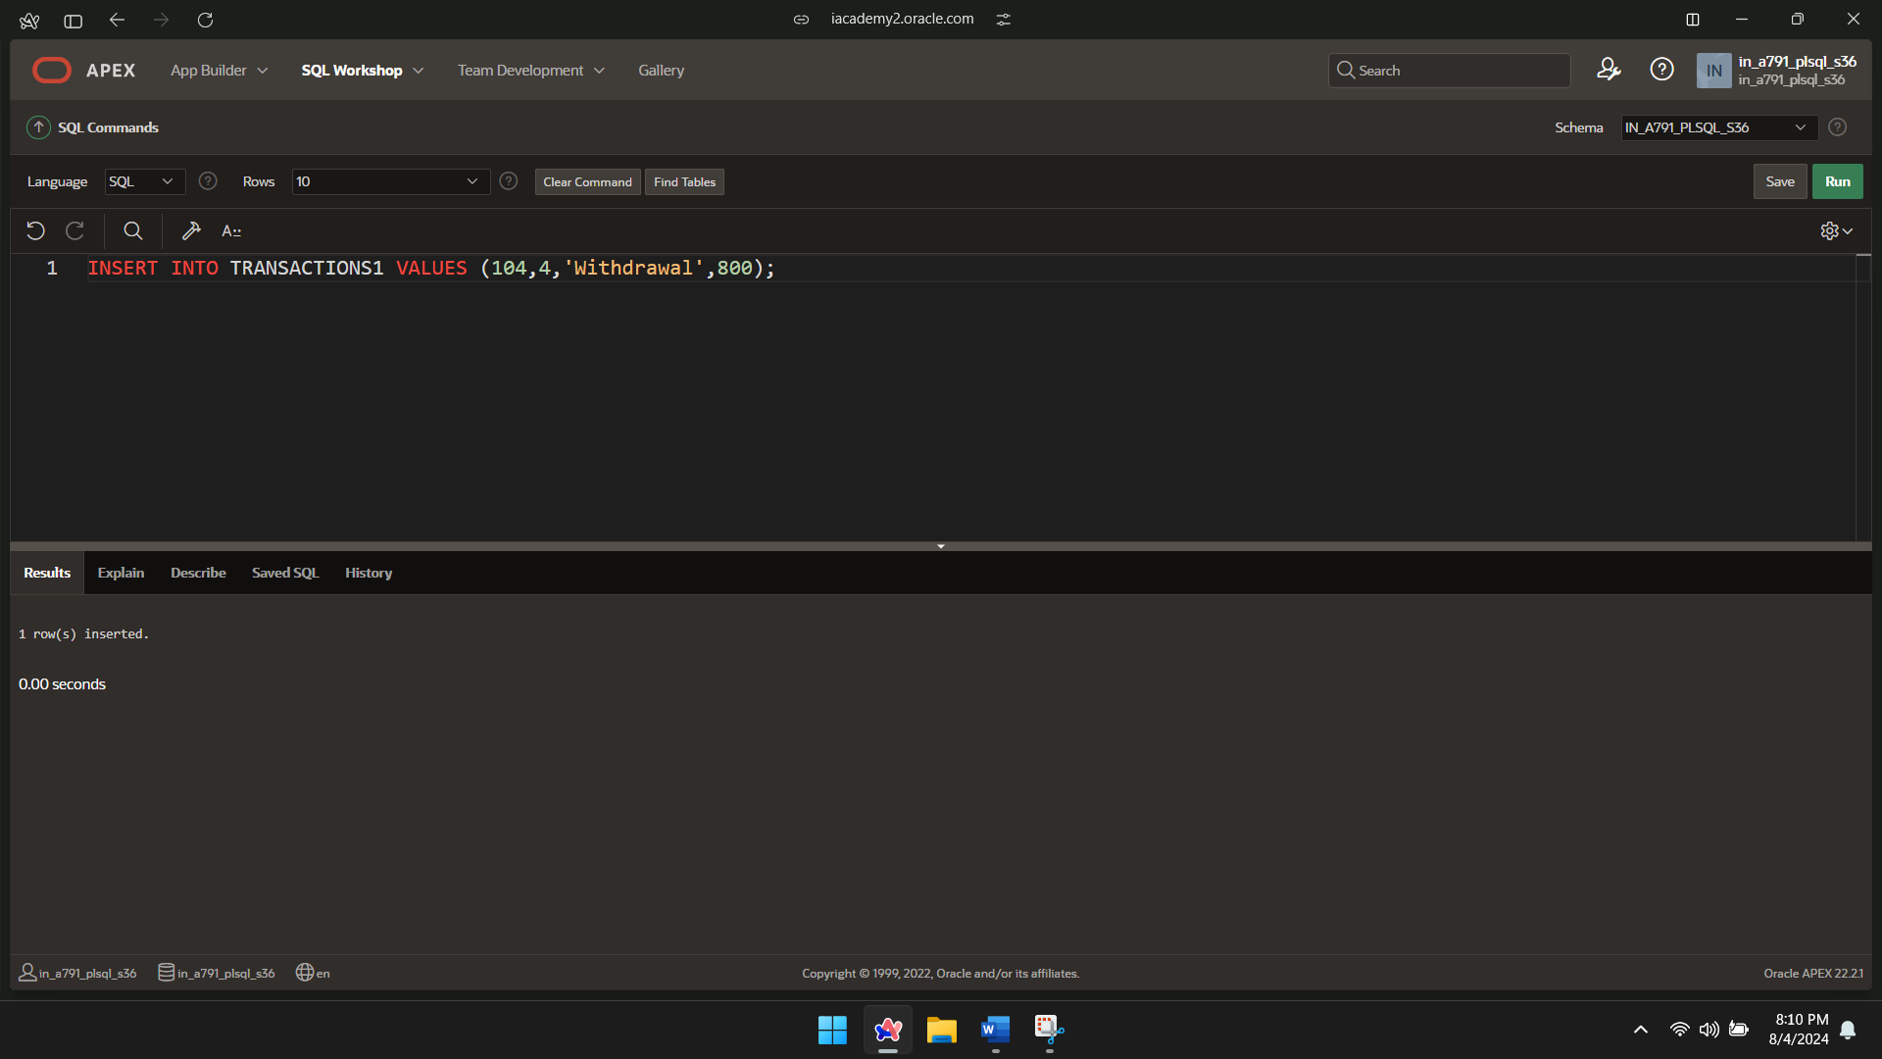

INSERT INTO TRANSACTIONS1 VALUES (105,5,'Deposit',2500);

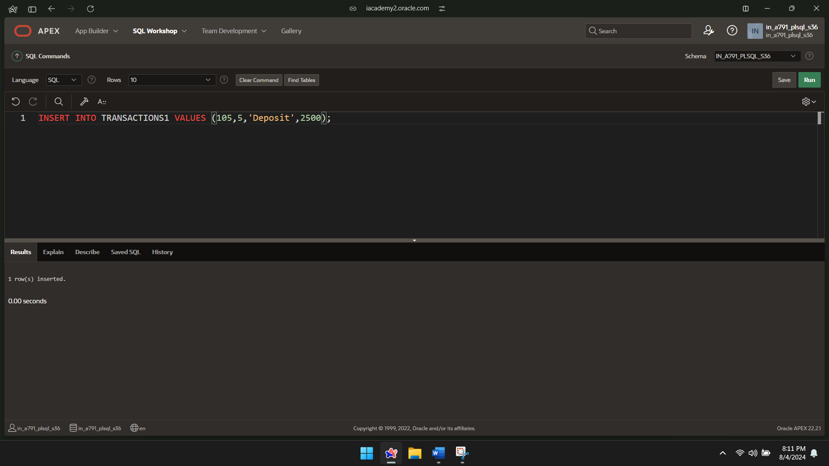

SELECT *FROM TRANSACTIONS1;

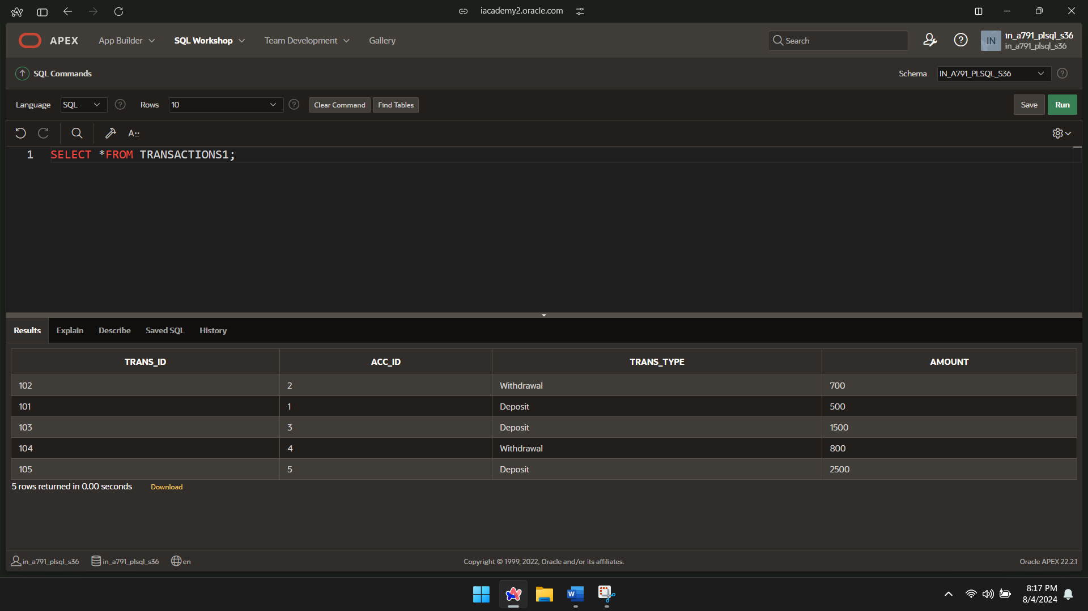

MERGE INTO BANKS1 b USING(

SELECT acc_id,amount

FROM TRANSACTIONS1

WHERE trans_type ='Withdrawal'

)t

ON(b.acc_id=t.acc_id)

WHEN MATCHED THEN

UPDATE SET b.balance=b.balance-t.amount;

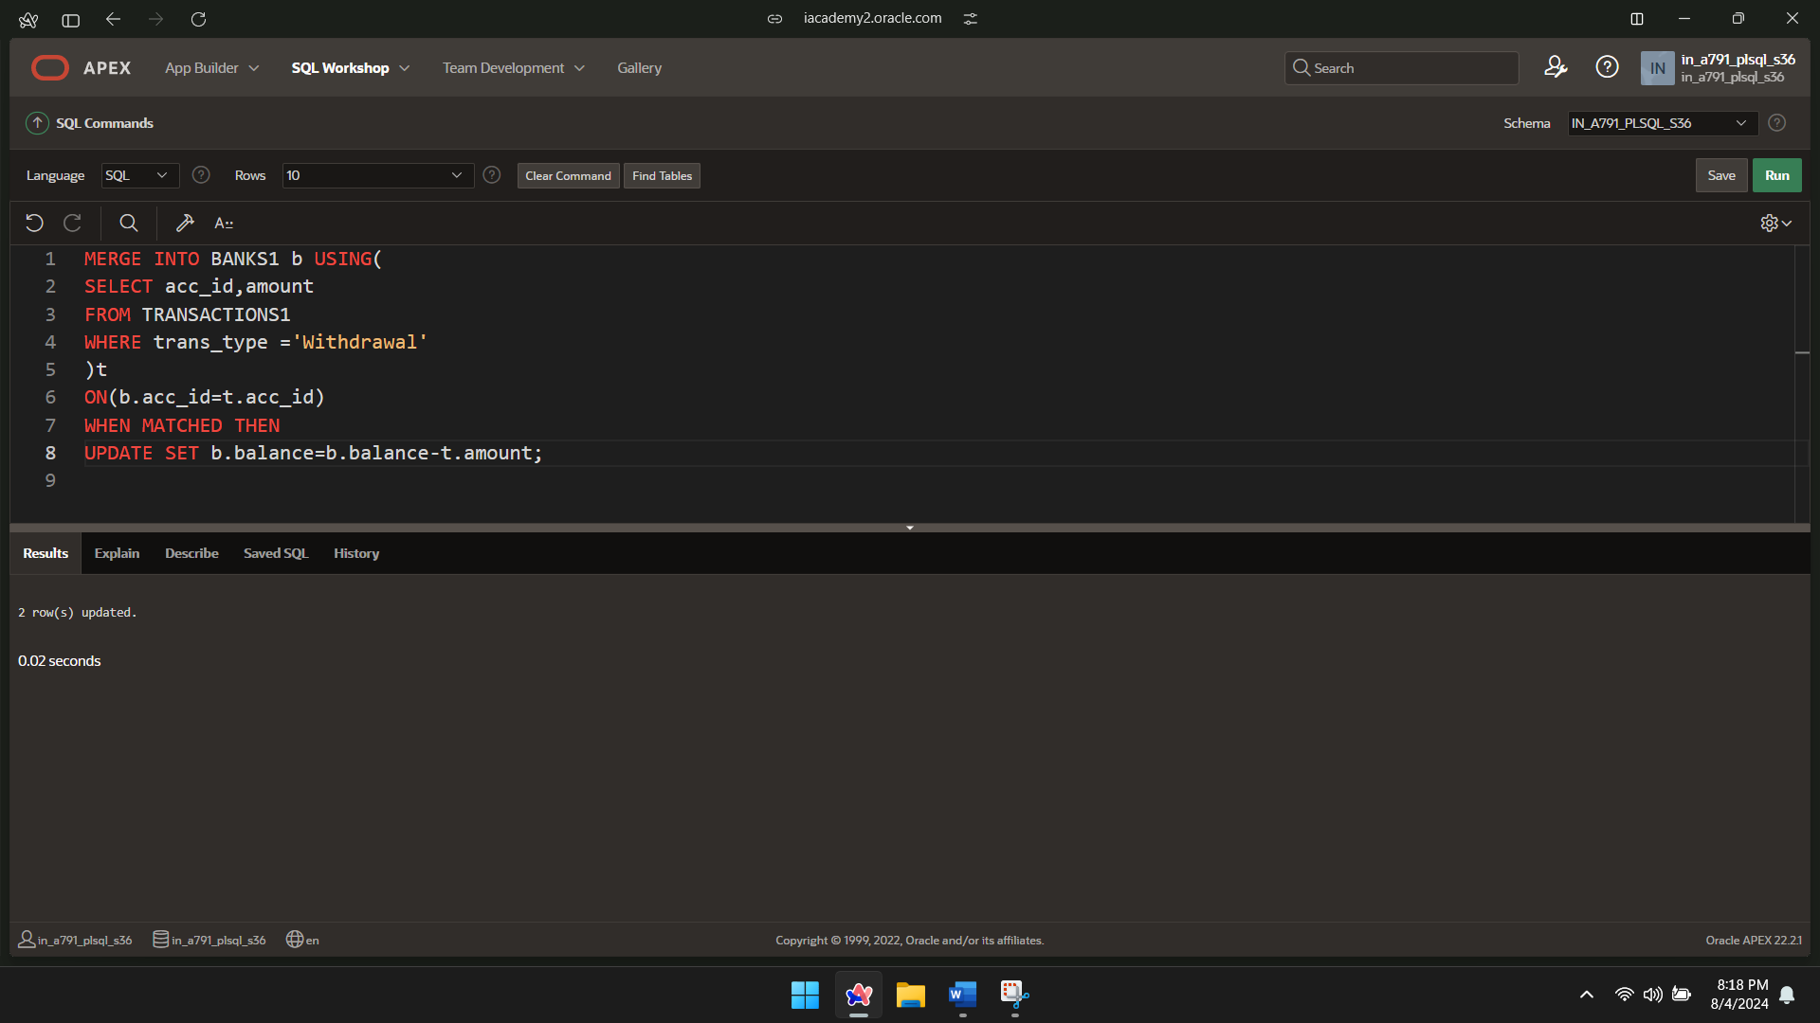

MERGE INTO BANKS1 b USING(

SELECT acc_id,amount

FROM TRANSACTIONS1

WHERE trans_type ='Deposit';

)t

ON(b.acc_id=t.acc_id)

WHEN MATCHED THEN

UPDATE SET b.balance=b.balance+t.amount;

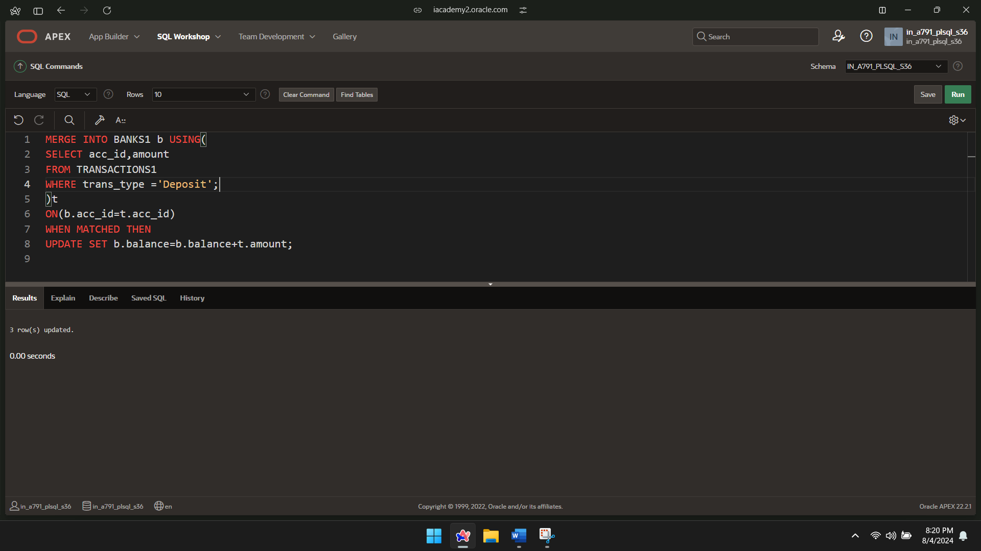

SELECT *FROM BANKS1;

